Module 2 – Functions

2.2 – Symmetry and Transformation of Graphs of Functions

(Use this reading guide along with section 2.5 of the text)

Symmetry
(see text pages 156-157)
A function with the property that has a graph which is symmetrical about the y-axis, so once we have graphed one half the other half comes “for free”. Expressions like which are expressed in terms of just even powers of x have this property, so all such functions are called EVEN functions. Similarly, functions satisfying are called ODD functions since they include sums of odd powers.
If f is either an even function or an odd function then just one half of its graph is enough to get the rest. Can you draw the complete graph of an even function and an odd function whose graphs include the part sketched below? (see answer #1)
Q1

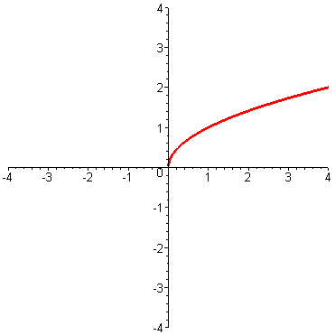

Shifting
(see text pages 158 and 159)

Adding a positive constant to the value of a function produces a new function whose graph is moved up – in the direction of increasing y. But adding a positive constant to the argument x moves the graph to the left – in the direction of decreasing x.

One way to understand this is to note that to graph what we plot at is the y-value of . That is, to find the y-value on our new graph we look on the old graph at the point c units to the right (if c>0). But if we reach to the right to find our values but that means that we will pull them to the left. Thinking “Reach right to pull left” may help you to remember the resulting effect on the graph. The apparent difference between x and y disappears if we note that is the same as . So adding c to the formula for y is the same as replacing y in the equation not by y+c but rather by y-c.

Scaling
(see text pages 160-162)

The scaling story is similar.
Q2
The graph of comes from by multiplying all y-values by c – which stretches the graph vertically if , and compresses it if , (and flips it across the x-axis if c<0).
But for multiplication of x to give the effect is reversed , i.e. if the graph of squashed sideways rather than stretched. Can you see how to explain this along the same lines as above for shifting? (see answer #2)

Combined Operations

For situations involving both addition and multiplication, it is safest to work in stages.
Q3
For example, to graph we need to consider both a shift and a scaling, but
it may be hard to guess the sequence of operations which produces the desired outcome.

See if you can do it for the function f graphed below. (see answer #3)

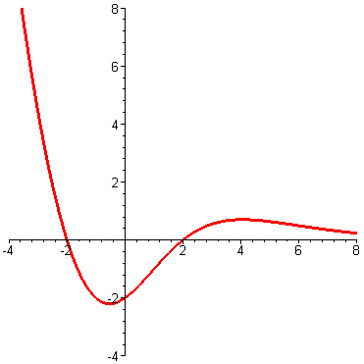

Piecewise Defined Functions
(text pages 162Example8-168)

These come up in applications like tax schedules as discussed on page 165-166.
The absolute value is also an example since
We discussed them also a bit in the previous unit. Can you write the piecewise defined function whose graph is given in Exercise #20 on page 151 from Section 1.4 of the text?
(see answer #4)

The “greatest integer function” discussed on pp166-167 is important in computing since it gives the result of “rounding down”. In many computer programming languages it is called the “floor” function. So .
This is useful for describing anything that goes up in steps like the cost of mailing a parcel as a function of its weight for example, so it is sometimes also called the “postage function”.

Application to Quadratic Functions

In section 2.6 of the text the above ideas are applied to the special case of quadratic functions – i.e. functions of the form . The main idea is that by factoring out the leading coefficient, a, and “completing the square” such functions can be written in a form () whose graph is obtained from just by shifting and scaling.

You might read section 2.6 now, but we will address it again in the next module so it won’t be included in the assignment for this module and you can leave it until later if you prefer.

Further Practice
Check your understanding and practice for speed by working through some of the Exercises on pages 169-172 of the text. Do enough of the odd numbered questions of each type to convince yourself that you can get the right answers.
As a bare minimum you should do ##1,5,17,27,31,37,41,47,51,55 and 65.
You might also experiment with our shift and scale applet to help build your understanding of how these transformations work.

Answers to Questions

1. For the even case the graph is symmetrical about the y-axis so the left half is just like the mirror image of the right (you might get it by marking the right half with wet ink and folding the two sides together along the y-axis). (see graph on left below)
And for the odd case the left half is obtained by first reflecting across the y-axis, and then also across the x-axis (or equivalently by rotating the right half by about the origin) to get the result shown on the right.

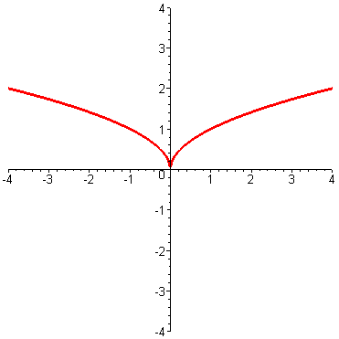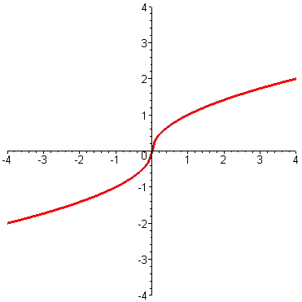

2. One way to understand this is to note that to graph what we plot at is the y-value of . That is, to find the y-value on our new graph we look on the old graph at the point c times as far from the y-axis (i.e. further away if and closer in if ). But if we reach out to find our values, that means that we will pull them in when we plot them (and vice versa). Thinking “Reach out to pull in” (and Reach in to pull out”) may help you to remember the resulting effect on the graph. The apparent difference between x and y disappears if we note that is the same as . So taking c times the formula for y is the same as replacing y in the equation, not by cy, but rather by .

3. Since what we know is the effect of replacing x by either cx or x+c, our goal is to describe the replacement of x by 2x+1 as two such steps.

But if we first replace x by 2x to get the squashed graph, then replacing the x here by x+1 gives , which is not what we want. To get we need to replace the x in with just , so a correct sequence is squash by 2 then shift left by half – as shown in the graph on the left below.
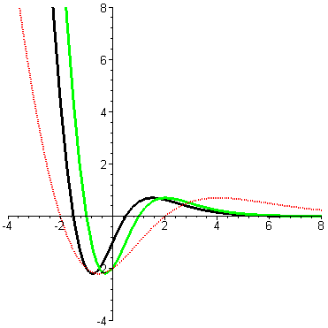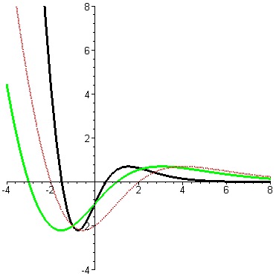

On the other hand, we can also get from x to 2x+1 if we first replace x by x+1 (shifting the graph left by one), and then replace x by 2x. So another correct sequence is first shift left by 1 then squash the result – as shown in the graph on the right above.

4.

