Module 2 – Functions

2.4 – Inverse Functions

Study Notes (for Text section 4.1)

In order for a function’s inverse relation to also be a function, it must be possible to determine the argument completely from the result, so there must be only one input giving each possible output. Functions with this property are said to be one-to-one
You should be able to test whether a function is one-to-one either algebraically as in the text’s Example 1, or graphically by the “Horizontal Line Test” (HLT) as in the text’s Example 2. If a function is always increasing, then as we read left to right its graph is always rising so it never hits the same value twice and so is one-to-one. The same applies if the function is always decreasing. Can you draw a function graph that is not either always increasing or always decreasing but is still one-to-one? (see answer #1)
Q1

Graphs of Inverse Functions

Since the equation just means that , the graph of comes from just by interchanging x and y , or in other words by reflecting across the diagonal . We don’t even need a formula in order to do this. For example, the function graph below passes the HLT so the function f has an inverse function which you should be able to graph without doing any algebra. (see answer #2)
Q2

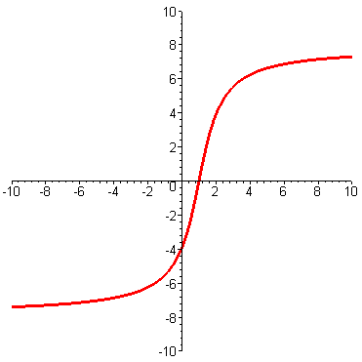
Finding Inverse Functions

If and f is one-to-one, then .

So if we can solve for x in the equation ,
then the result must be a formula for , and to get we just have to replace y by x in the resulting formula.

It also works to go the other way, since if then ,
so solving for y in terms of x after switching should lead to the same result.

Try this second approach with the text’s Example#3 on page 284. (see answer#3)

Further Practice

Check your understanding, and practice for speed, by working through some of the Exercises on pages 288-290 of the text (at the end of Section 4.1).

Do enough of the odd numbered questions of each type to convince yourself that you can get the right answers. (Note that, as usual, the answers are in the back of the text and complete worked solutions are in the student study guide - but try to avoid looking at answers or solutions until you have made your own best effort)

As a minimum, you should try ##1, 7, 11, 17, 21, 27, 31, 37, 41, and 53.

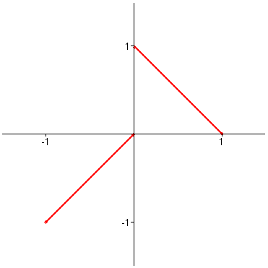

Answers to Questions

- Here’s one possible example

2.
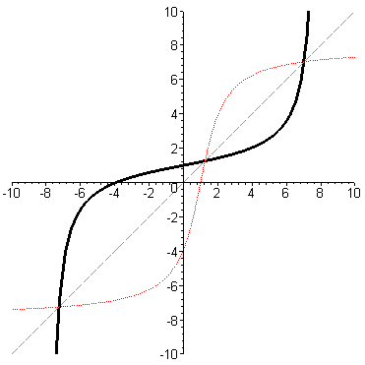

Note that the y-intercept of the graph of is the same as the x-intercept for f, and vice-versa. Also, where the graph of f crosses the line , the graph of does also.

3. For , if then .
This gives , and . But here y is . So

