Module 3 – Polynomial and Rational Functions

3.4 – Rational Functions
(see Text section 3.5)

Introduction
The ratios of polynomials studied algebraically in the previous section are known as Rational Functions. In this section we shall investigate the graphs of such functions and look at some further applications.

Study Notes and Discussion

Every polynomial is also a rational function. Why? (See answer #1)
Q1

The simplest non-polynomial rational function is given by .
The graph of this function should already be familiar to you.
When |x| is large, is small, and vice versa, so the graph has a horizontal asymptote at , and a vertical asymptote at .

We can graph many related functions by shifting and scaling. For example, the graph in Example 1 of the text is just the graph of shifted to the right by 2 units.
Q2
More generally, comes from by what steps? (See answer #2)

Sometimes a bit of algebra will enable you to express a given function in this form.
Q3
Try using this to graph and (See answer#3&answer#4)
Q4
In all of the above examples the graph has the same basic shape. But if the numerator and/or denominator have higher degree, then it may be more complicated.

In particular, will be undefined wherever its denominator is zero.
At such points, the graph may have a vertical asymptote as does at .
But in other cases it may just have a missing point or “hole”. The text’s Example 4 illustrates this.

Note: The text’s “Guidelines for Sketching . . .” on page 255 refer specifically just to the case where numerator and denominator “have no common factors”. If there are common factors of on top and bottom, then the graph is almost the same as what you get after canceling them out. In fact for every x not equal to c, the cancellation is valid. But the result after cancellation might be defined at whereas the given function is not. A graphing strategy that will work in such cases is as follows:

- First, factor the denominator and draw in a lightly dotted vertical line at each point where the denominator is zero – but do not assume that these will all be asymptotes.
- Next, make the cancellation of common factors and graph the resulting reduced function using the book’s “Guidelines”, but be sure to darken and label as “V.A.” only the vertical asymptotes that you identify in “Step 2”, and when drawing your graph just ignore any of the lines from our previous step that do not get labeled.
- Finally, wherever the graph you have drawn crosses one of those vertical lines that did not turn out to be an asymptote, erase a small gap and draw in a little circle to draw attention to the “hole” in the graph.

Another situation not covered in those “Guidelines” is the case of oblique asymptote (also known as a slant asymptote) that is discussed in the text’s Example#9. In fact, the behaviour of a rational function for large |x| (i.e. as ) depends on the difference of degrees and is similar to that of the quotient polynomial obtained by long division.
-If the degree of the numerator is less than that of the denominator then the graph has a horizontal asymptote at ,
-If the degrees are equal, then there is a horizontal asymptote at ,where a is the ratio of leading coefficients,
-If the degree on top is exactly one more than that on the bottom, then there’s an oblique asymptote whose equation is given by the result of long division, and
-If the degree on top is more than one more than that on the bottom, then the large |x| behaviour of the graph is like a polynomial of degree d where d is the difference of degrees.

Actually, now that you know the whole story, this should be the first thing you look at.
So your graphing strategy might best be to first check degrees and if appropriate find the oblique asymptote. Then factor the denominator and so on as described above.
So, putting it all together, we get a general strategy that goes as follows:

I Check degrees of numerator and denominator, and
- if denominator has higher degree then indicate a horizontal asymptote (HA) at ;
- if degrees are equal indicate a HA at ratio of leading coefficients;
- if numerator has higher degree indicate end behaviour depending on the degree difference and the sign of the ratio of leading coefficients, and if the degree difference is exactly one, use long division to find the oblique asymptote.

II Factor numerator and denominator, then
- at roots of the denominator indicate that the function is undefined ;
- check for cancellation and indicate locations of vertical asymptotes (VA).

III Using the simplified function (after cancelling) follow the book’s guidelines to
- locate potential intercepts;
- check signs in each interval between x-intercepts and/or VA’s;
- if there is a horizontal or oblique asymptote, check for crossings (as in step 5 of the book’s guidelines);
- graph the simplified function.

IV Indicate holes at points on the simplified function’s graph where the original function is not defined.
Q5
Try using these steps to graph . (See answer #5)

Determining Rational Functions From Their Graphs
Can you identify a rational function whose graph has the following properties?
Q6
Vertical asymptote at with on both sides, x-intercept at , hole at (0,0), and horizontal asymptote at ? (See answer #6)

Further Practice

Check your understanding and practice for speed by working through some of the Exercises on p264-267. Do enough of the odd numbered questions of each type to convince yourself that you can get the right answers. As a minimum, do at least #13,21,33,41, 45 and 51.

Answers to Questions
1. , is a ratio of polynomials since the constant 1 is a polynomial of degree 0

2. Scale by A vertically then shift by D vertically, and scale to multiply horizontal distances by 1/b, then shift horizontally by c. If you have trouble seeing how this differs from doing the shifts before the scaling, then you might want to review Module2.2 (esp. Q3).

3. You could sketch this quickly by noting that it has a vertical asymptote at , a horizontal one at , no sign changes anywhere else, and a y-intercept at .
(See left graph below.) This does look like a shifted and scaled version of .
In fact, since , we see by the previous result that the graph comes from by squashing sideways by a factor of 2 and then shifting left by (or shifting left by , then scaling vertically by a factor of ).

4. The algebraic trick here is to write , or use long division, to get . So the graph of comes from by shifting left by 1, stretching vertically by a factor of 2, reflecting across the x-axis, and finally shifting up by 1. This gives a vertical asymptote at , a horizontal asymptote at , and the y-intercept at . (See right graph below.)

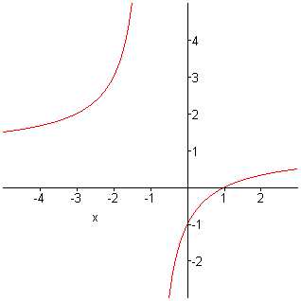
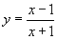
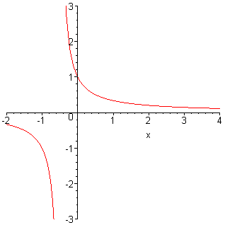
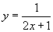

5. Long division gives a quotient of , so there’s a slant asymptote at .
Factoring gives zeros of the denominator at and at (a double root). The factor of x in the denominator is cancelled by one of those in the numerator and the simplified form for the function is . The graph of has x-intercepts with sign changes at 0,2, and -2 and a VA at with no sign change. Matching these conditions and marking the hole at gives the graph below.

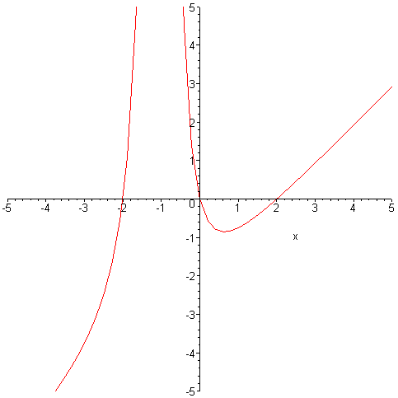

6. is one possibility.

