view as .doc

Module 4 – Exponential and Logarithmic Functions

Section 4.3 – Logarithms and Logarithmic Functions

Introduction

If a site is contaminated with a radioactive material of half life one week so that the level of radiation is now ten times the safe level, how long will it be before it is safe?

Using the formula with where is the safe level, we need to find t giving , i.e. such that .
So we need to find the exponent t in the equation .

Clearly t=3 is not enough, since after 3 weeks the radiation level will have been multiplied by and so . But by t=4 the radiation will be below the safe level, so the solution is somewhere between 3 and 4.

If we want to find exactly when the safe level is reached then we need to solve the equation exactly.

The solutions to such exponential equations are called logarithms.

Section Learning Objectives

When you have finished this section you should be able to:
- State the definition of logarithms as solutions to exponential equations
- Explain the shapes of logarithmic function graphs in terms of their inverse function relation to exponentials
- Translate equations involving exponentials into logarithmic language and vice versa
- Recognize and solve applied problems requiring the use of logarithms

Study Plan

1. Review Section 4.1 of the text and the notes on Inverse Functions in Module 2
2. Use the following Reading Guide to section 4.4 of the text.
3. Read the Summary Notes and use the questions to check your understanding.
4. Follow the instructions regarding Practice Exercises.
Reading Guide

p315-16
Read the definition on page 315. Note that the definition amounts to saying that
is the power to which the base a must be raised to get result x. (That this is a uniquely defined function of x is a consequence of the fact that simple exponentials are one-to-one.) So if x is given as a power of a (or easily recognized as such) then we know the logarithm.
e.g. Since , ; and since , .

p317
As inverse functions to simple exponentials, logarithms are also 1:1 and have graphs which can be found by reflecting exponential graphs across the line y=x. Note that the domain of is the same as the range of , i.e. . So logarithmic functions are undefined when evaluated at negative arguments. Thus when we solve an equation like Example#3 on page 317, we MUST check the solution (just like for equations involving radicals).

For example if asked to solve for x in log(4x-15)=log(2x-9), we might follow the same procedure as in Example#3, and we would find x=3. But when x=3, 4x-15 and 2x-9 are both negative, and so neither side of the equation actually makes sense! So in fact it has no solutions.

p318-325
Examples #5-9 on p.318-320 are just exercises in shifting and scaling like those in sec2.5

In many applications relationships are expressed in terms of logarithms with base 10, or base e. Base 10 logs were popular when logarithm tables were used to shortcut multiplication and often the symbol log without a base is used for these “common logs”. Base e has nice mathematical properties (related to the slope property of ) and so logs with base e are called “natural logs” and denoted by ln.
The examples on pages 321-325 use the standard notational conventions just mentioned. i.e. log without a base refers to (called “common” logarithm),
and ln is shorthand for (called the “natural” logarithm).

The Richter scale is one of several situations where logarithms are used because of the psychological fact that we tend to perceive successive multiples of the physical scale of a phenomenon as equally spaced. This means that our intuitive notion of magnitude corresponds to the logarithm of the physical quantity. (Other examples include stellar magnitude for brightness of stars, and the decibel scale for loudness of sounds.)

Examples#13&14 show how to find doubling or halving times from a given continuous growth rate and so involve solving exponential equations with base e which uses natural logs.
The main points to remember are as follows:

is the power to which the base a must be raised to get result x. (That this is a function of x is a consequence of the fact that simple exponentials are one-to-one.) So if x is given as a power of a (or easily recognized as such) then we know the logarithm.
e.g. Since , ; and since , .

In many applications relationships are expressed in terms of logarithms with base 10, or base e. Base 10 logs are convenient because they tie in to our decimal number system, and often the symbol log without a base is used for these “common logs”. Base e has nice mathematical properties (related to the slope property of ) and so logs with base e are called “natural logs” and denoted by ln.

As inverse functions to simple exponentials, logarithms are also 1:1 and have graphs which can be found by reflecting exponential graphs across the line y=x. Note that the domain of is the same as the range of , i.e. . So logarithmic functions are undefined when evaluated at negative arguments. Thus when we solve an equation like Example#3 on page 309 of the text, we MUST check the solution.
To see why this is necessary, consider what would happen if we were asked to solve for x in a similar looking problem, namely log(4x-15)=log(2x-9). If you follow the same procedure as in Example#3, you will find x=3.(You should be able to do this yourself.) But when x=3, 4x-15 and 2x-9 are both negative, and so neither side of the equation actually makes sense! So in fact it has no solutions.

Since they are defined as solutions of exponential equations, it is not surprising that a major use of logarithms is for solving such equations.

For example, our problem in the Introduction has a given doubling time and so gives an exponential function with base ½ and we want to find when the radiation level has been reduced to one tenth of its starting value. i.e. we want to solve for t in
The answer to that problem is easily given in terms of , as follows.
Since we want , we must have .
Many calculators will let you enter this directly to get an approximate numerical value, but some more basic models just have log and ln. You will learn how to express general logs using just these special ones in the next sections.

Another class of applications of logarithms arises from the psychological fact that we tend to perceive successive multiples of the physical scale of a phenomenon as equally spaced. This means that our intuitive notion of magnitude corresponds to the logarithm of the physical quantity. One example of this is the Richter scale for describing earthquakes which is described in Example#11 in the text. (Other examples include stellar magnitude for brightness of stars, and the decibel scale for loudness of sounds.)

Summary Notes and Discussion

Definitions

The logarithm of the number x with respect to the base a, which we write as, is the power to which the base a must be raised to get the result x.
Thus , and .

That is a uniquely defined function of x is a consequence of the fact that simple exponential functions are one-to-one, and in fact each logarithm function is just the inverse function of the exponential function with the same base.

If x is given as a power of a (or is easily recognized as such) then we know the logarithm.
e.g. Since , ; and since , .

What are a) , b) ? (See answer #1)

In many applications, relationships are expressed in terms of logarithms with base 10, or base e. Logarithms with base 10 are convenient because they tie in to our decimal number system. They are called “common logs” and are often written using the symbol log without a base. Base e has nice mathematical properties (related to the slope property of ) and so logs with base e are called “natural logs”. The symbol ln is often used in place of .

Graphs of Logarithms and Related Functions

As inverse functions to simple exponentials, logarithms are also one-to-one and have graphs which can be found by reflecting exponential graphs across the line y=x. Note that the domain of is the same as the range of , i.e. .
Other functions related to logs can be graphed by shifting and scaling. To test your understanding draw a quick sketch of .(See answer #2)

Solving Equations Involving Logarithms

If is given, then x is easily found as that power of a. e.g. if , then 3 is the power to which 2 must be raised to give result x. So .
What is the solution of ? (see answer #3).

The one-to-one property allows us also to solve equations of the form
by just “removing the logarithms” to get (so long as each side is a single logarithm and both logs have the same base).
This is demonstrated in Example#3 on page 317 of the text.

But logarithmic functions are undefined when evaluated at negative arguments. Thus when we solve an equation like that example, we MUST check the solution (just like for equations involving radicals).

To see why this is necessary, consider what would happen if we were asked to solve for x in a similar looking problem, namely log(4x-15)=log(2x-9). If you follow the same procedure as in Example#3, you will find x=3. But when x=3, 4x-15 and 2x-9 are both negative, and so neither side of the equation actually makes sense! So in fact the equation has no solutions.

Note also that this use of the one-to-one property for “cancelling of logs”only works when each side is just a single log term. For example log(100)+log(1000)=log(100000), but removing the logs gives something that is definitely not true!

Solving Exponential Equations

Since logarithms are defined as solutions of exponential equations, it is not surprising that a major use of logarithms is for solving such equations. For example, if , then x must be . What is the solution of ? (see answer #4)

Our problem in the Introduction has a given half life and so gives an exponential function with base ½, and we want to find when the radiation level has been reduced to one tenth of its starting value. So we need to solve for t in .
The answer to that problem is easily given in terms of , namely .
Many calculators will let you enter this directly to get an approximate numerical value, but some more basic models just have log and ln.(Recall that log without a base means and ln means .)You will learn how to express general logs using just these special ones in the next sections.

Applications of Logarithms

In the above examples of applied problems involving logarithms, the logarithms have been introduced to help us solve equations involving exponentials. In fact there are also applied situations where we may want to go the other way – i.e to solve an equation which is given to us in terms of logarithms. Such equations may arise when some quantity is defined in terms of the logarithm of another. Many applications of this type arise from the psychological fact that we tend to perceive successive multiples of the physical scale of a phenomenon as equally spaced. This means that our intuitive notion of magnitude corresponds to the logarithm of the physical quantity. One example of this is the Richter scale for describing earthquakes which is described in Example#11 in the text. (Other examples include stellar magnitude for brightness of stars, and the decibel scale for loudness of sounds.)

Further Practice

Check your understanding and practice for speed by working through some of the Exercises on pp.325-330.

Do enough of the odd numbered questions of each type to convince yourself that you can get the right answers. (Note that, as usual, the answers are in the back of the text and complete worked solutions are in the student study guide - but try to avoid looking at answers or solutions until you have made your own best effort)

As a minimum you should do ##1,5,11,15,21,35,41,51,61,71

Answers to Questions
1. (a) since ,
(b) since ,

2.
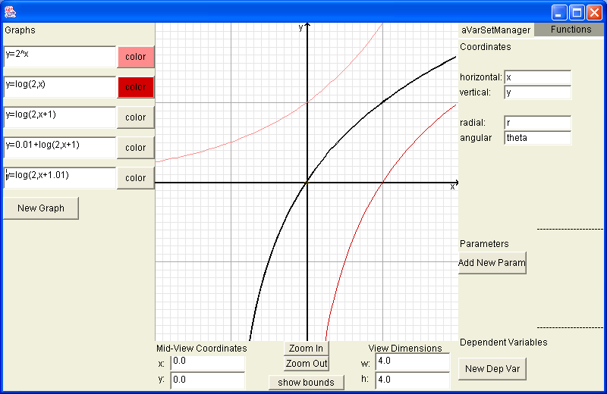

3. If , then is the power to which e must be raised to give x.
So .

4. If , then (or just log(50))

