Module 5-II – Trigonometric Functions

5-II.4 – Inverse Trig Functions, Equations and Inequalities

Introduction

Both in module 5-I and in section 5-II.1 of this module we have briefly addressed the problem of finding angles from given trig ratios. This amounts to solving for t in an equation like where v is a given value. In this section we shall look at such problems in more detail and will also find angles from more complicated equations involving their trig ratios.

Section Learning Objectives
After completing this section you should be able to:
- Solve simple trig equations either by recognizing particular special cases and/or by reference to “inverse trig functions”
- Use identities and algebraic manipulation to solve more complicated equations
- Solve various applied problems involving trigonometric equations and inequalities

What to Do

1. Read section 6.2 of the text.
2. Read the following Study Notes.
3. Read section 6.6 of the text.
4. Read the Follow-up Notes and Discussion
5. Follow the instructions regarding Further Practice.

Study Notes

In the text section 6.2 (that you have just read), the basic equations like (and similarly with cos and tan) were combined with algebraic steps like factoring to solve more complicated equations. (This is much like what we did in Unit 4.5 with exponential and logarithmic equations.) But everything still depends on the solution of those basic equations and we only have exact solutions for special cases.

To solve for general v we have been relying on the calculator’s button to get an approximate solution, so it would be a good idea to look more closely at what this button actually does.(Especially since we know that trig functions all fail the HLT and so don’t actually have inverse functions at all – so the name on that button must be a lie! )

We know that when the calculator is in radian mode the button applied to input v produces a solution of the equation . But we also know that there are infinitely many possible solutions. Clearly the button picks just one – but which one?

The answer, as discussed in more detail in the text’s section 6.6, is that the result produced by the button is always between and ,(i.e. it always corresponds to a positive or negative acute angle). What does this correspond to in terms of the circle picture? (see answer #1)

Although the sine function is not invertible, the function defined by restricting the sine function to the interval , is one-to-one and so does have an inverse function. Its graph consists of just that part of the sine graph between and . This does pass the HLT, and its reflection across the diagonal gives the graph of its inverse function. Can you draw these? (see answer #2)

The function defined by the calculator’s button is just exactly the inverse function of the above defined function S. It is not really the inverse function of the sine itself (in fact there isn’t one), but nonetheless it is often denoted by and called the “inverse sine function”. Since this is not strictly correct, many authors prefer a different name and call it the arcsine function as discussed on p511 of the text.

The corresponding stories for the calculator’s and buttons are similar, except that tan is undefined at and , so the restriction is to just the open interval , and for cos, the interval between and does not work, and so is used instead. Try reflecting the graph of across the diagonal, and compare the result with you got for the arcsine above. (see answer #3)
Doing the same thing for the arctan leads to the graph in Figure 8 on page 525 of the text.

Follow-up Notes and Discussion

In your reading of section 6.6 of the text, you will have seen that .
The restriction is necessary because the left hand side (LHS) is undefined unless x is in the domain of the arcsine (which is the same as the range of the sine).

You will also have seen that
.
In this case though, the LHS is defined for all x, (since is defined for all x and is always between -1 and 1 and so in the domain of ). But if , then , which is in that interval, cannot be the same as x, which is not.

Similar comments apply to the compositions of cos with arccos, and tan with arctan.

Try to sketch the graphs of and without a calculator
(then use a calculator or the GraphExplorer to check your answer).

The text’s Examples 4, 6, and 8 all involve composition of one trig function with the inverse of another. This is a fancy way of asking you to find other trig ratios of an angle for which one ratio is given (as you did way back near the beginning of our trig study in Unit 5.3). Pay attention to the identity proved in Example 8. That is something you will find important later on when studying Calculus.

Further Practice

Check your understanding, and practice for speed, by working through some of the Exercises on pp521-524 and 479-482.

Do enough of the odd numbered questions of each type to convince yourself that you can get the right answers. (Note that, as usual, the answers are in the back of the text and complete worked solutions are in the student study guide - but try to avoid looking at answers or solutions until you have made your own best effort)

As a minimum, you should try the following: From section 6.2 #1,5,31,35,55, and 75,
and from section 6.6 #1,11,21,31,41,51,61,67, and 71.

Answers to Questions

1. It means that of the two points on the unit circle at height v, the one corresponding to the angle produced by the button is the one on the right hand side of the y-axis.

2.
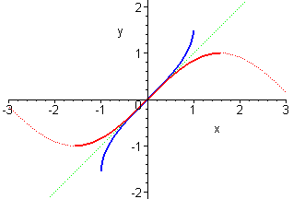

3.
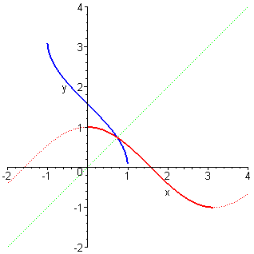

Notice that this inverse cosine graph has the same domain as the inverse sine but different range. (In each case the range of the inverse function is the domain to which we restricted before inverting.) Also, the inverse cosine is decreasing in a way that appears exactly opposite to the way the inverse sine is increasing. Thus it should not be surprising that their sum is a constant . You will see this proved when you read the text’s Example 10 (on page 508).

